## **Name : Junaid Ahmed**

## **ID: BIT-23F-030**

## **Section: “3A”**

## **Lab: 06**

## **Subject: Artificial Intelligence**

## **Program: BS-IT**

TASK-01 : Write a Python function that takes a number as input and returns the sum of its digits.

## Program:

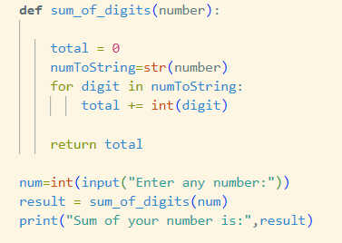

## Output:



TASK-02 : Write a Python function that takes a sentence as input and returns the number of words in it.

## Program:

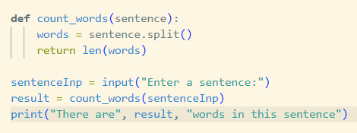

## Output:



TASK-03 : Write a Python function that takes an integer and returns whether the number is even or odd.

## Program:

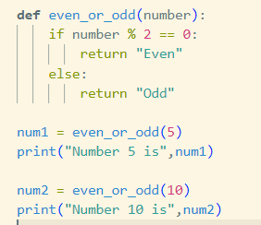

## Output:

